Assignment No:6

Name: Prasanna Khebade Roll No: 15 PRN: 12311687 Div: CS (AI) – B

Title: Understanding protocol stack of Intranet.
Problem Statement: Analyze packet formats of Ethernet, IP, TCP and UDP captured through Wireshark for wired networks.
Course Objective: To learn transport layer and application layer protocols used in the Internet.
Course Outcome: Develop Client-Servers by the means of correct standards, protocols and technologies.
Tools Required: Wireshark.
Theory:
1. Introduction
Wireshark is a network packet analyzer. A network packet analyzer presents captured packet data in as much detail as possible. You could think of a network packet analyzer as a measuring device for examining what’s happening inside a network cable, just like an electrician uses a voltmeter for examining what’s happening inside an electric cable (but at a higher level, of course). In the past, such tools were either very expensive, proprietary, or both. However, with the advent of Wireshark, that has changed. Wireshark is available for free, is open source, and is one of the best packet analyzers available today.
1.1 Features
The following are some of the many features Wireshark provides:
- Available for UNIX and Windows.
- Capture live packet data from a network interface.
- Open files containing packet data captured with tcpdump/WinDump, Wireshark, and many other packet capture programs.
- Import packets from text files containing hex dumps of packet data.
- Display packets with very detailed protocol information.
- Save packet data captured.
- Export some or all packets in a number of capture file formats.
- Filter packets on many criteria.
- Search for packets on many criteria.
- Colorize packet display based on filters.
- Create various statistics.

2. Wireshark Filter
2.1 Display Filter
Wireshark provides a display filter language that enables you to precisely control which packets are displayed. They can be used to check for the presence of a protocol or field, the value of a field, or even compare two fields to each other. These comparisons can be combined with logical operators, like "and" and "or", and parentheses into complex expressions.
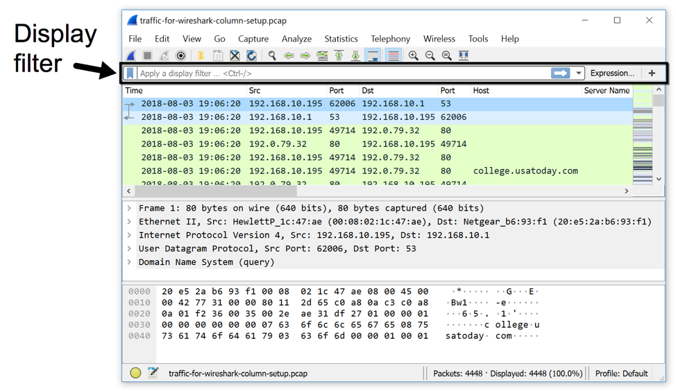
Wireshark's display filter uses Boolean expressions, so you can specify values and chain them together. The following expressions are commonly used:
- Equals: == or eq
- And: && or and
- Or: || (double pipe) or or
2.1.1 Example
- eth.src == 00:11:22:33:44:55: Source MAC address is 00:11:22:33:44:55
- ip.addr == 10.0.0.1: Find all traffic that has IP of 10.0.0.1
- tcp.dstport != 80: Destination tcp port is NOT 80
- ip.addr==10.10.10.1
- ip.addr==192.168.1.10 && ip.addr==192.168.1.20
- !(ip.addr==192.168.1.10 && ip.addr==192.168.1.20)
- (ip.addr==192.168.1.10 && ip.addr==192.168.1.20) && (tcp.port==445 || tcp.port==139)
- ip.src==10.10.10.0/24
- eth.addr==00:1b:17:00:01:31
- ip.addr==10.10.10.1 && tcp.port==80
- tcp.port==80
- tcp.port==80 || tcp.port==3389
- tcp.dstport==80
- eth.dst=ff:ff:ff:ff:ff:ff
- ip.addr==255.255.255.255
ip.host contains "imap"

2.2 Capture Filters
Capture filters are used to decrease the size of captures by filtering out packets before they are added. Capture filters enable you to capture only traffic that you want to be captured, eliminating an unwanted stream of packets. Capturing packets is a processor-intensive task, and packet analyzers use a good amount of primary memory while they are running. Packets are only sent to the capture engine if they meet a certain criterion (capture filter expressions). Capture filters do not facilitate advanced filtering options, as in display filters.
2.2.1 Examples
Capture only traffic to or from IP address 172.18.5.4:
- host 172.18.5.4
Capture traffic to or from a range of IP addresses:
- net 192.168.0.0/24
or
- net 192.168.0.0 mask 255.255.255.0
Capture traffic from a range of IP addresses:
- src net 192.168.0.0/24
or
- src net 192.168.0.0 mask 255.255.255.0
Capture traffic to a range of IP addresses:
- dst net 192.168.0.0/24
or
- dst net 192.168.0.0 mask 255.255.255.0
Capture only DNS (port 53) traffic:
- port 53
Capture non-HTTP and non-SMTP traffic on your server (both are equivalent):
- host www.example.com and not (port 80 or port 25)
host www.example.com and not port 80 and not port 25
Capture except all ARP and DNS traffic:
- port not 53 and not arp
Capture traffic within a range of ports
- (tcp[0:2] > 1500 and tcp[0:2] < 1550) or (tcp[2:2] > 1500 and tcp[2:2] < 1550)
or, with newer versions of libpcap (0.9.1 and later):
- tcp portrange 1501-1549
Capture only Ethernet type EAPOL:
- ether proto 0x888e
Reject ethernet frames towards the Link Layer Discovery Protocol Multicast group:
- not ether dst 01:80:c2:00:00:0e
Capture only IPv4 traffic - the shortest filter, but sometimes very useful to get rid of lower layer protocols like ARP and STP:
- ip
Capture only unicast traffic - useful to get rid of noise on the network if you only want to see traffic to and from your machine, not, for example, broadcast and multicast announcements:
- not broadcast and not multicast
Capture IPv6 "all nodes" (router and neighbor advertisement) traffic. Can be used to find rogue RAs:
- dst host ff02::1

Conclusion:
Hence, we have Successfully Capture packets using Wireshark and wrote the exact packet capture filter expressions.

Example:
1. Identify Facebook.com IP Address
sudo apt-get install traceroute
traceroute facebook.com
traceroute to facebook.com (163.70.143.35), 30 hops max, 60 byte packets

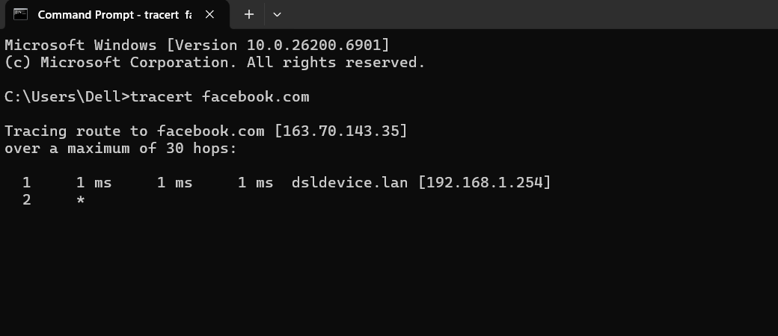

2. Capture all TCP traffic to/from Facebook, during the time when you log in to your Facebook account.
Capture filter: tcp and host 163.70.143.35

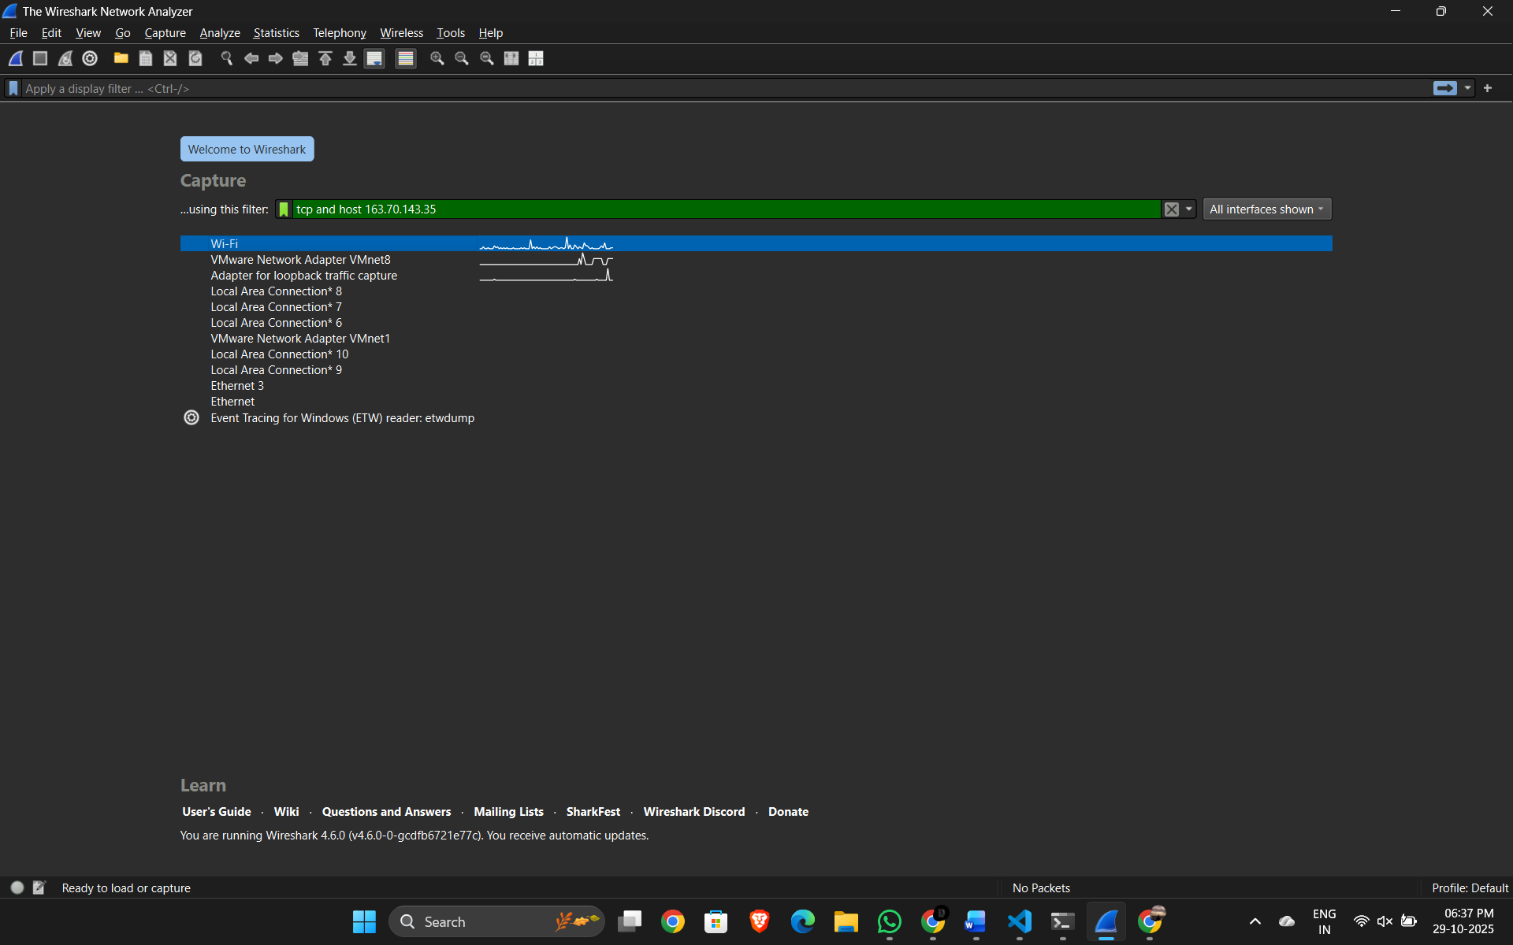

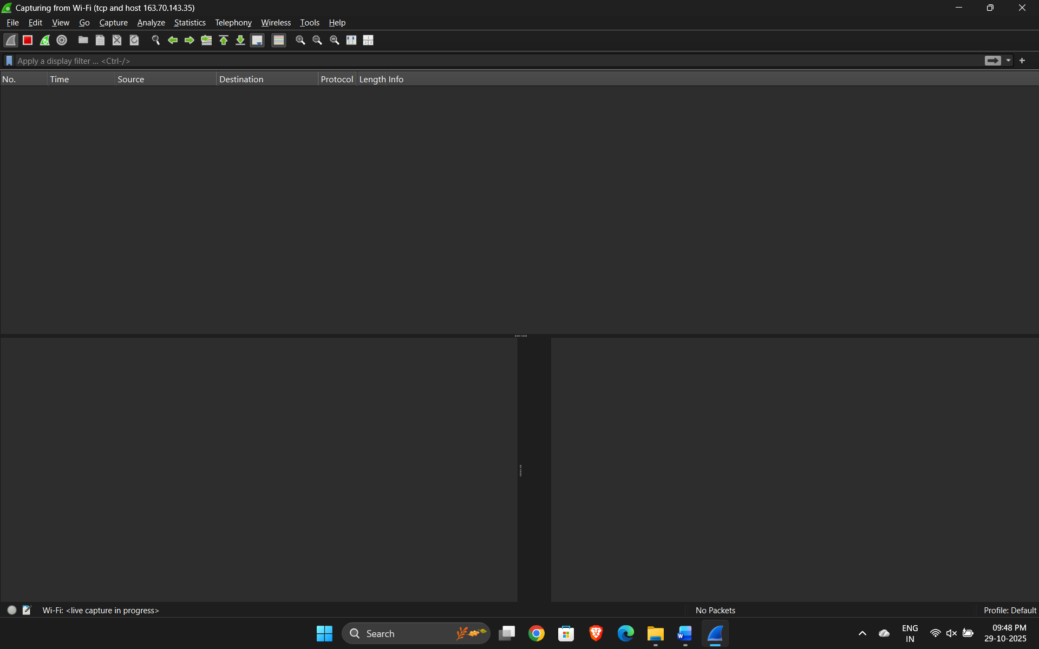

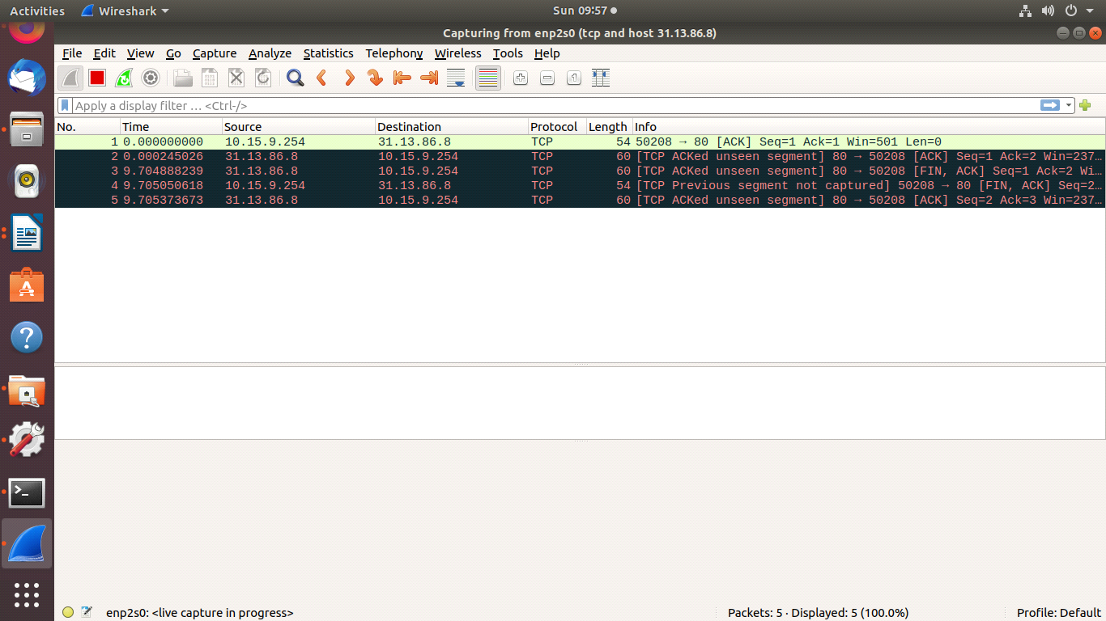
3. Capture all HTTP traffic to/from Facebook, when you log in to your Facebook account
Capture filter: tcp port 80 and host 163.70.143.35
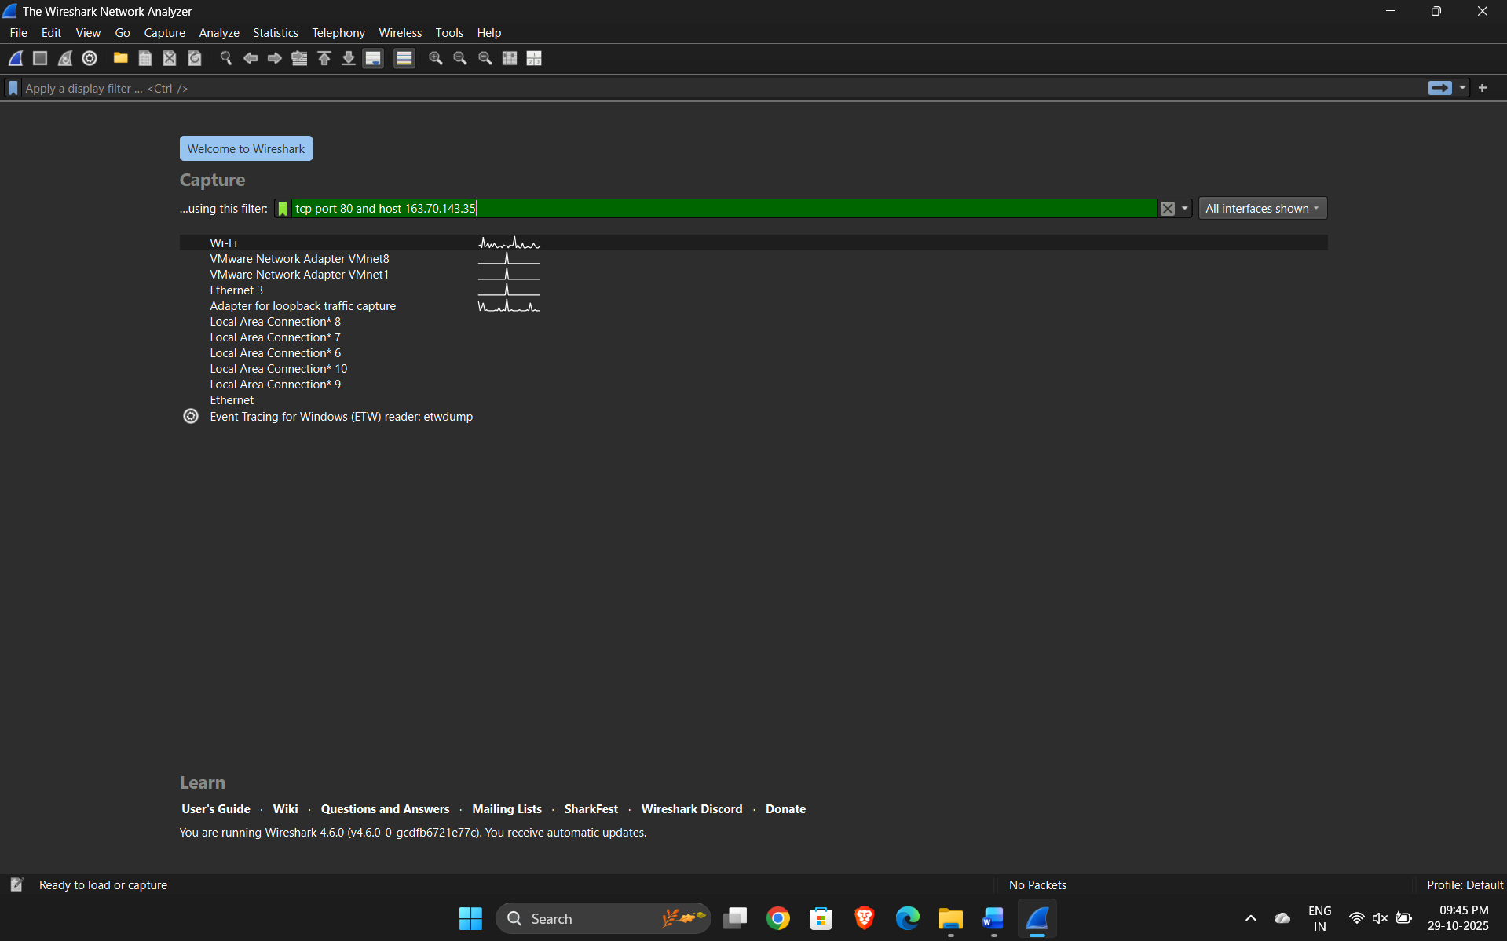
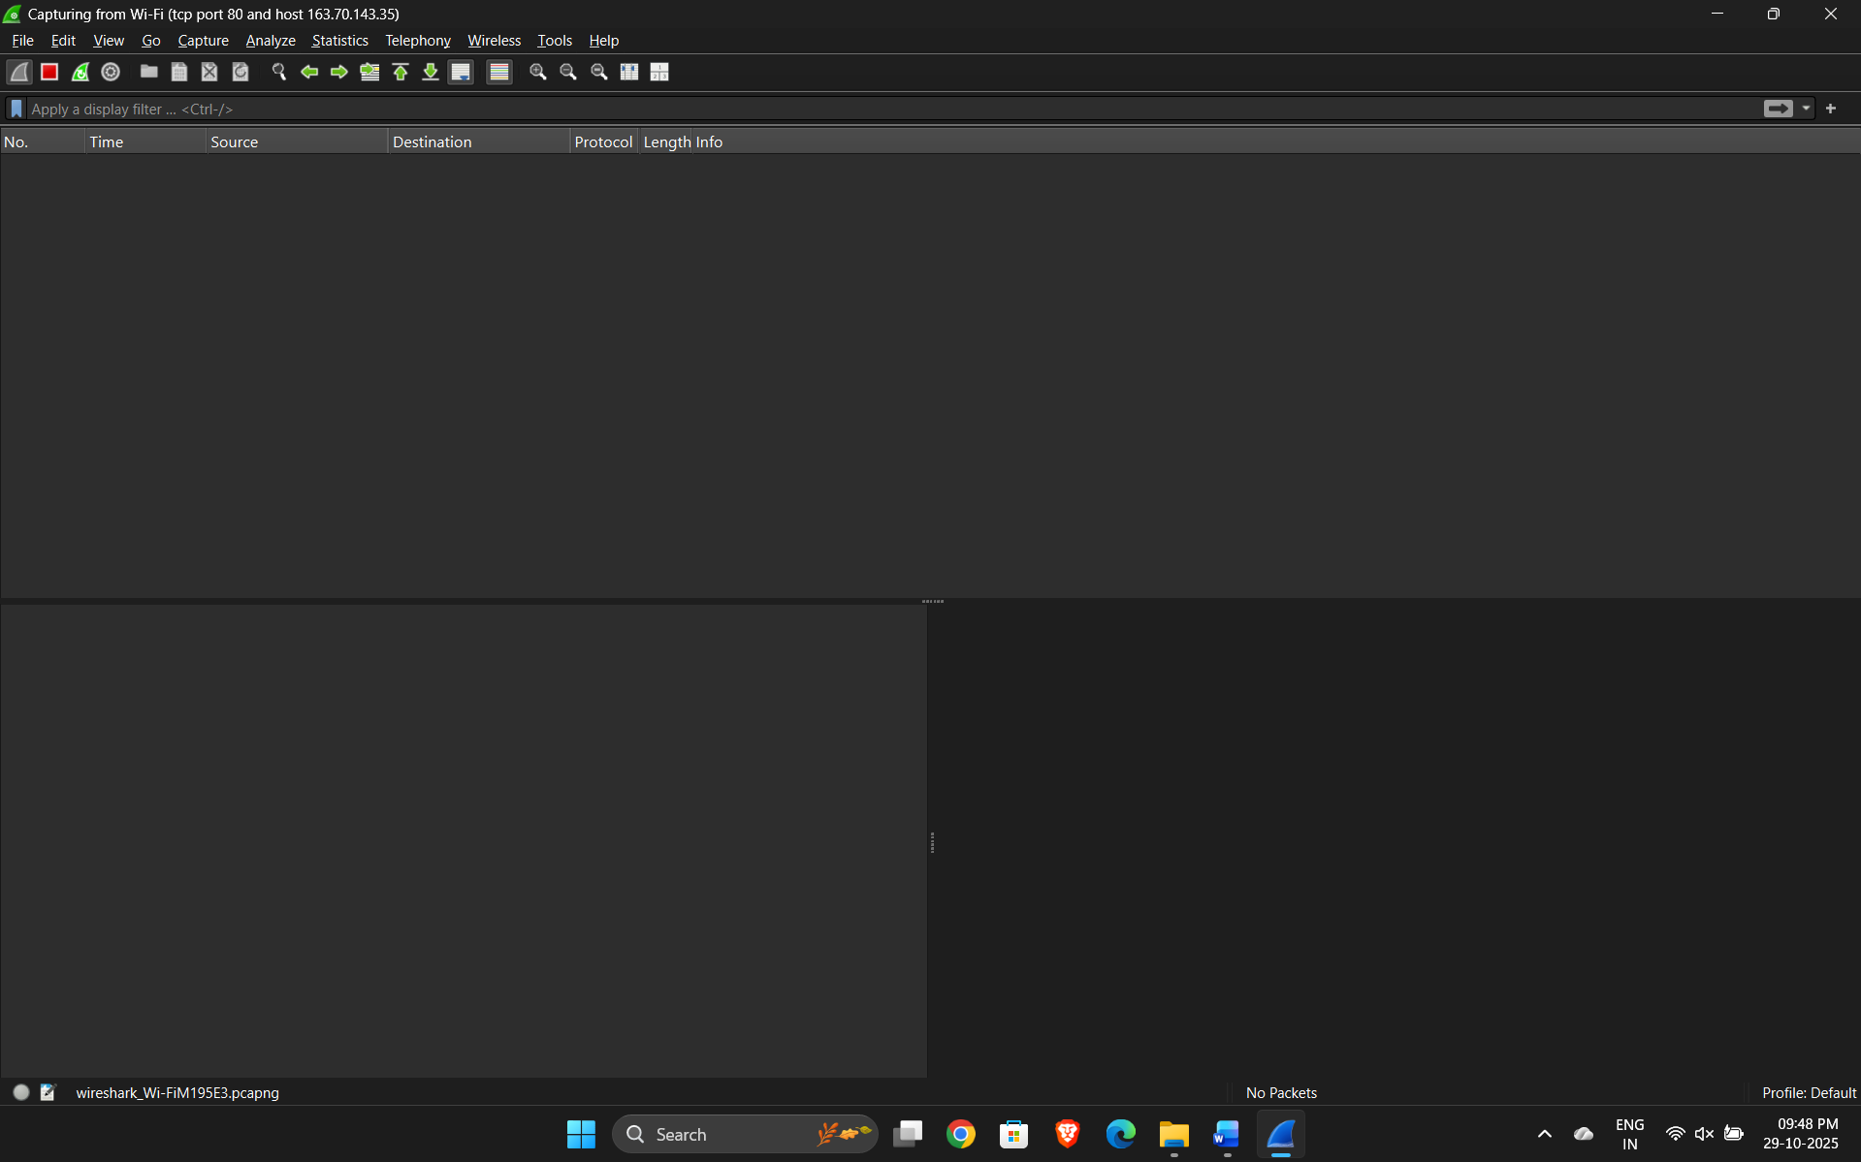
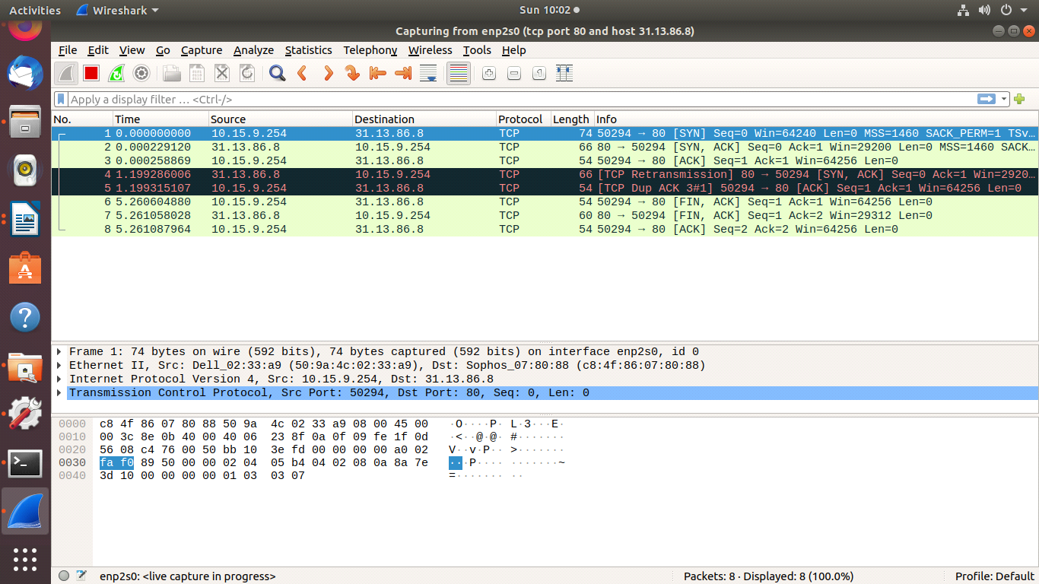

4. Write a DISPLAY filter expression to count all TCP packets (captured under item #1) that have the flags SYN, PSH, and RST set. Show the fraction of packets that had each flag set.
DISPLAY filter:
tcp.flags.syn==1 && ip.dst==163.70.143.35
tcp.flags.push==1 && ip.dst==163.70.143.35
tcp.flags.reset==1 && ip.dst==163.70.143.35

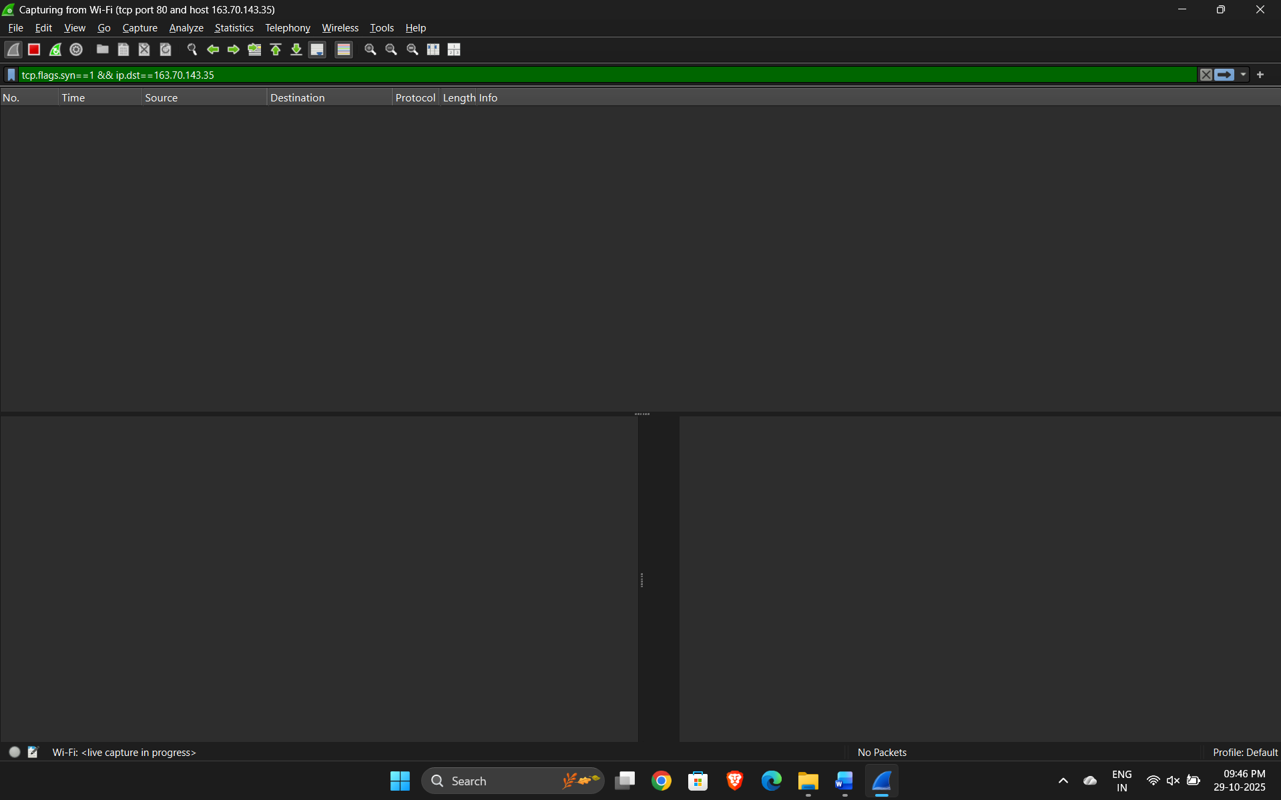

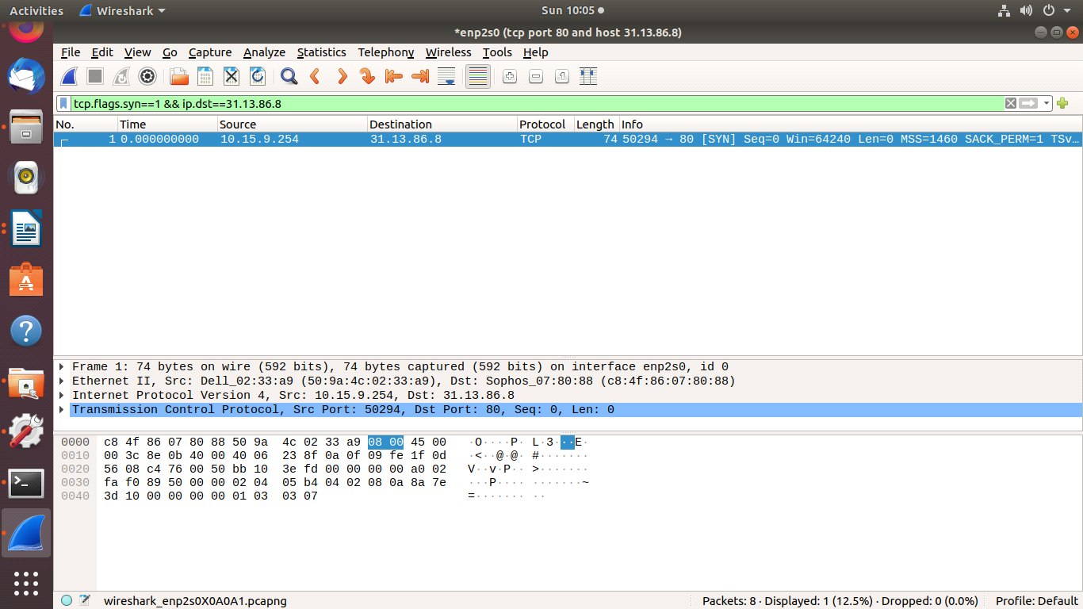
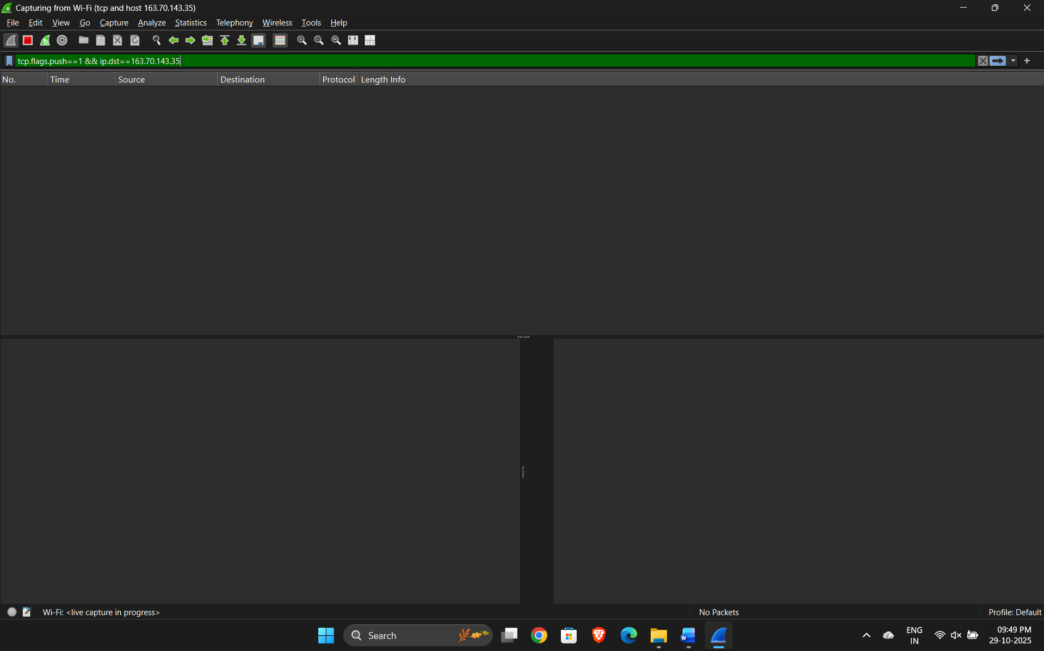
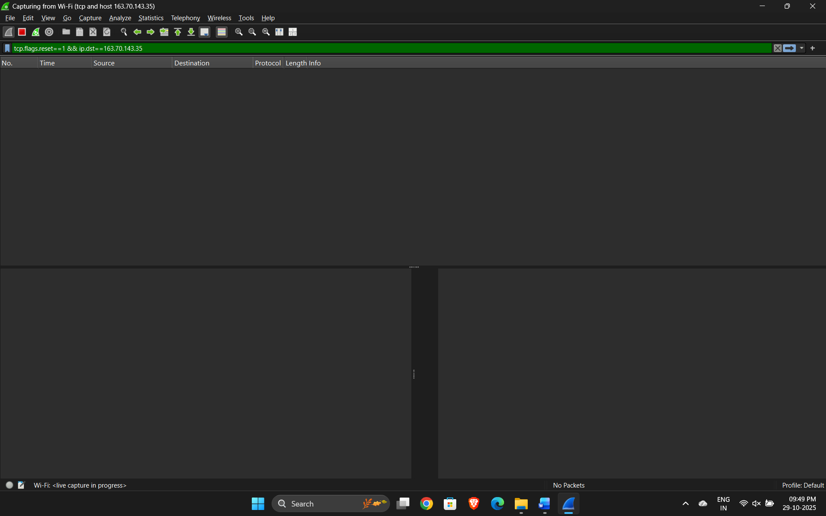
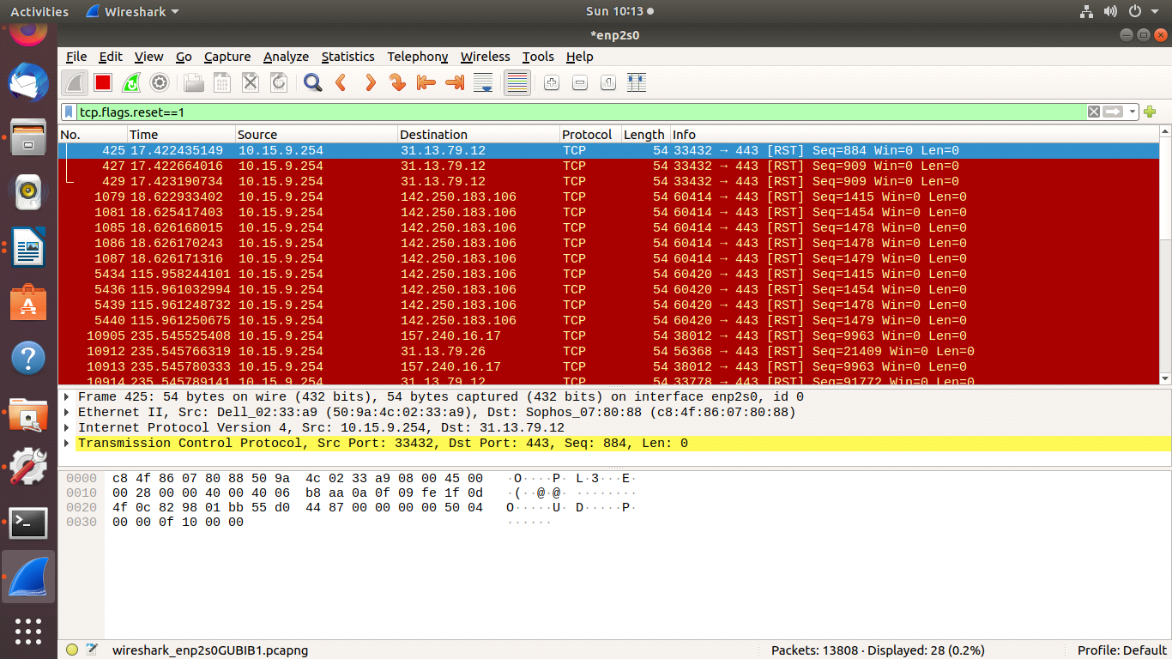
5. Count how many TCP packets you received from / sent to Face book, and how many of each were also HTTP packets.
